TreeSim
Use Case Specification

Submitted to:

Asst. Prof. Ma. Rowena C. Solamo
Faculty Member
Department of Computer Science
College of Engineering
University of the Philippines, Diliman

Submitted by:
Albano, Romeo Senen D.
Endaya, Jeynald Jeyromme L.
Quiñones, Yzabel Iesa M.

In partial fulfillment of academic requirements
for the course
CS 191 Software Engineering I
of the
1st Semester, AY 2014-2015
Revision Control

History Revision:
Revision Date | Person Responsible | Version  Number | Modification
09/30/14 | Romeo Albano  Jeynald Endaya  Yzabel Quiñones | 1.0 | Initial Document;
10/27/14 | Jeynald Endaya | 1.1 | Formatting changes and checking for anything to revise.

Use-Case Name: 1.0 Use Simulation Module

Description: This use case describes the main functionality of the program, wherein the user simply makes use of a simulation module. The user is first presented with a list of simulation modules to choose from, where each item in the list represents an algorithm or a builder for a tree. After the user chooses a module, the user will provide the required inputs (parameters for MGCV, and commands for MCGI), which the program will then process to generate the simulation. For an MCGV, the user may choose to input another set of parameters to repeat the simulation, and for an MCGI, the user may continue to give additional commands.

Preconditions: There are available module choices for the user.

Flow of Events:
Scenario Name | Description
Scenario 1 (Basic Flow)  The simulation module was successfully used. | 1. The user selects a simulation module from the simulation catalog.  2. Depending on the selected simulation module, either Use Case 1.1 MCGV: Input Initial Parameters or Use Case 1.2 MCGI: Input User Commands will be performed.  3. The User will then view the simulation generated by the program using the given user input. The User may go back to Step 1 to choose a new simulation or Step 2 to modify the generated simulation.  4. Use Case 2.0 is performed.  5. The use case ends successfully.
Scenario 2  The user gives an invalid input. | If Step 2 in the Basic Flow fails, i.e. the user enters an invalid input, the program repeats Step 2 to get the input from the User again.

Activity Diagram of the Flow of Events:
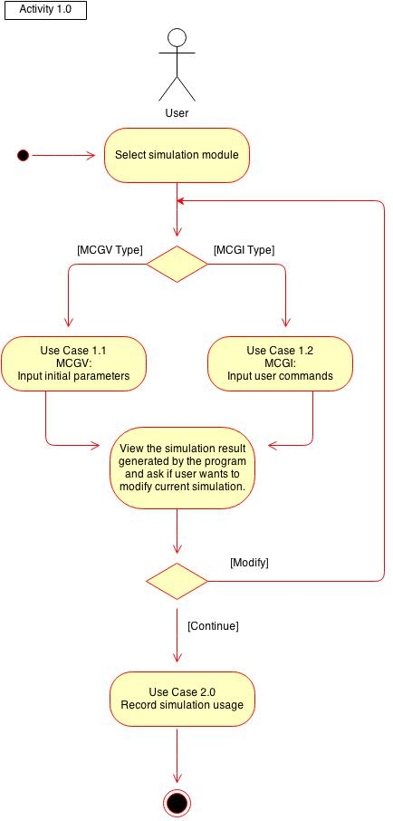

Place here the activity diagram. Make sure that the diagram is grouped as one and text does not wrap around the diagram.

Postcondition: Successful completion: The program has generated the desired simulation using the given input from the User.

Relationships: This use case is extended by Use Case 1.1 MCGV: Input Initial Parameters and Use Case 1.2 MCGI: Input User Commands.

Special Requirements: NONE

Use-Case Name: 1.1 MCGV: Input initial parameters

Description: For the MCGV simulations, this use case is where the user inputs the initial parameters for the demonstration of the algorithm. Parameters can range from choosing a preset tree, to creating a tree as input into the program. The application will inform the user of the needed parameters once they open the simulation.

Preconditions: NONE

Flow of Events:
Scenario Name | Description
Scenario 1 (Basic Flow)  The Modifiable Computer Generated Video (MCGV) is simulated successfully to the user. | 1. The use case begins when the program asks for the correct input for the selected simulated video module from the User. The correct input depends on the simulation module.  2. The user will fill in the input fields or requirements with the appropriate input. The program will guide the user through this process with questions.  3. The program interprets the inputs as the parameters for the algorithm described in the module.  4. The program creates a video (a preset sequence of operations to a tree) showing each step in the algorithm and executes it onscreen.  5. The program asks the user if he/she would like to give additional inputs, a new set of inputs to the simulation module.  6. The User inputs his/her choice. If the user wants to give more input or a new set, the program goes back to step 1. Otherwise, the program goes to step 7.  7. The use case ends successfully.
Scenario 2  The user gives an invalid input. | If Step 2 in the Basic Flow fails, i.e. the User enters an invalid input, the program repeats Step 1 to get the input from the User again.

Activity Diagram of the Flow of Events:
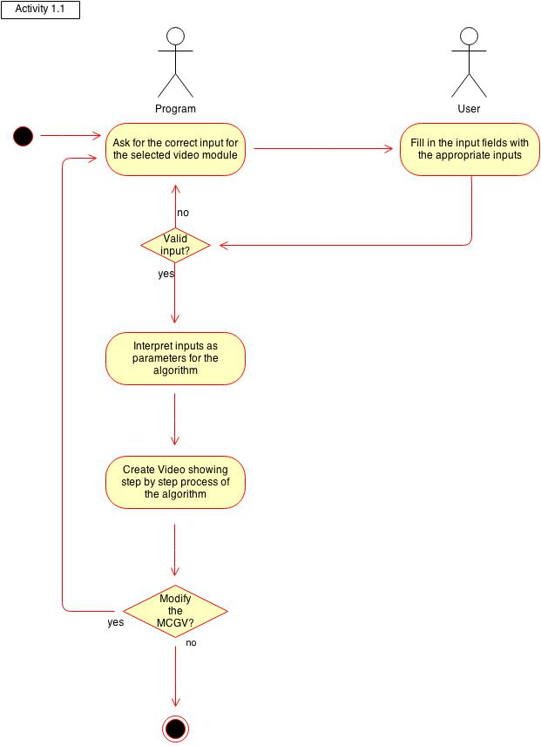

Place here the activity diagram. Make sure that the diagram is grouped as one and text does not wrap around the diagram.

Postcondition: Successful completion: The program has generated and played a video simulating the algorithm described by the module.

Relationships: This use case extends the Use Case 1.0: Use Simulation Module

Special Requirements: NONE

Use-Case Name: 1.2 MCGI: Input user commands

Description: Instructions will be given to the user as they go along this part. For MCGI simulations or the “tree builder” modules, the users will actually continually execute actions. Ideally, they will keep doing this until they’re satisfied and have understood the algorithms involved (such as the deletion of nodes in the tree).

Preconditions: NONE

Flow of Events:

Scenario Name | Description
Scenario 1 (Basic Flow)  The user creates the Modifiable Computer Generated Imagery (MCGI) and uses it successfully until he/she has understood the concept. | 1. The use case begins when the program asks for the build commands for the selected simulated tree module from the User.  2. The User will input the specified command that the User wants to do in building the specified tree.  3. The program performs the command given to the MCGI.  4. The program executes the visualization of the command given and displays it to the user.  5. The program awaits additional commands for the MCGI, allowing the user to view the tree at this time. If the user inputs a new command, the program goes back to step 2.  6. The use case ends successfully.
Scenario 2  The user gives an invalid input. | If Step 2 in the Basic Flow fails, i.e. the User enters an invalid input, the program repeats Step 1 to get the input from the User again.

Activity Diagram of the Flow of Events:
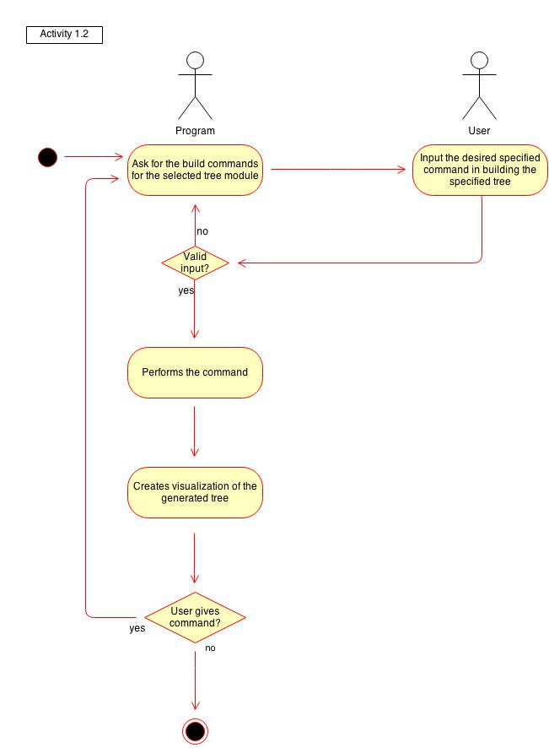

Place here the activity diagram. Make sure that the diagram is grouped as one and text does not wrap around the diagram.

Postcondition: Successful completion: The program has generated a tree simulating the algorithm described by the module.

Relationships: This use case extends Use Case 1.0: Use Simulation Module

Special Requirements: NONE

Use-Case Name: 2.0 Record simulation use

Description: In this use case, the usage tracker is activated by the user accessing a particular simulation. This recorder tracks the number of times the simulation has been opened as well as the total amount of time spent on each of the modules. While these measurements do not directly determine whether the user finds the topic hard, they can still be good indicators for the difficulty of the topic.

Preconditions: NONE

Flow of Events:
Scenario Name | Description
Scenario 1 (Basic Flow)  Simulation use is successfully recorded | 1. The use case begins when the Usage Tracker identifies the simulation module being used by the User.  2. The Usage Tracker finds the simulation's particular usage record by iterating through the records in the local module database.  3. The Usage Tracker increments the use count and the total elapsed time in the local module database once the user has finished with the simulation module.  4. The use case ends successfully.

Activity Diagram of the Flow of Events:
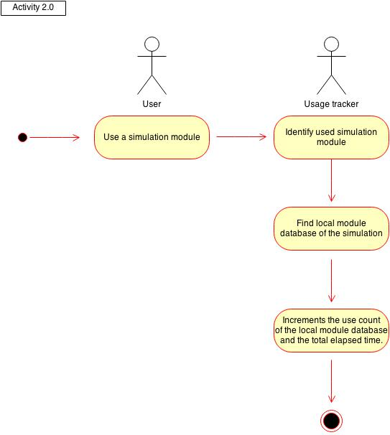

Place here the activity diagram. Make sure that the diagram is grouped as one and text does not wrap around the diagram.

Postcondition: Successful completion: The local module database of the used simulation is updated.

Relationships: This is included in the Use Case 1.0: Use Simulation Module

Special Requirements: NONE

Use-Case Name: 3.0 Update Usage Statistics

Description: The usage tracker collects all the statistics from the different simulation modules into one centralized document. This document is known as the usage statistics document, and this is actually the file displayed whenever the user views the usage statistics. Whenever the users run simulation modules, the usage tracker maintains and updates the usage statistics document.

Preconditions: NONE

Flow of Events:
Scenario Name | Description
Scenario 1 (Basic Flow)  The usage statistics document is updated. | 1. The use case begins when the Usage Tracker examines the first local module database in the set of databases.  2. The Usage Tracker records the usage count in the local module database to the central statistics database.  3. The Usage Tracker repeats step 2 for all local module databases until all are updated in the central statistics database.  4. The use case ends successfully.

Activity Diagram of the Flow of Events:
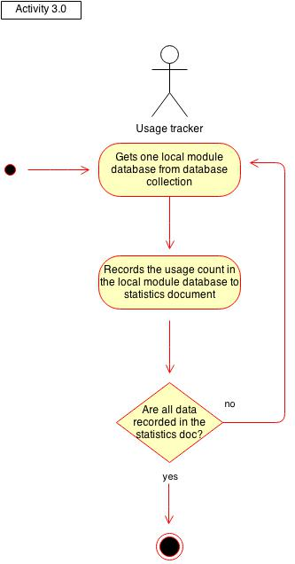

Place here the activity diagram. Make sure that the diagram is grouped as one and text does not wrap around the diagram.

Postcondition: Successful completion: The usage statistics document is updated.

Relationships: This use case is included in Use-Case 4.0 View usage statistics.

Special Requirements: NONE

Use-Case Name: 4.0 View usage statistics

Description: The user (students or teachers) can choose to view their usage statistics document in the program. This document contains data such as the amount of times the user has used a particular simulation and how much total time they’ve spent on it. Take note that this document only measures local usage. This means that it will only measure the way the application is being used on the device it is on (ie. No online databases).

Preconditions: NONE

Flow of Events:
Scenario Name | Description
Scenario 1 (Basic Flow)  The usage statistics document is presented to the User | 1. The use case begins when the User chooses to view the usage statistics document.  2. Use Case 3.0 is performed.  3. The Usage Tracker generates a report based on the data in the central statistics database and the program displays this.  4. The use case ends successfully.

Activity Diagram of the Flow of Events:
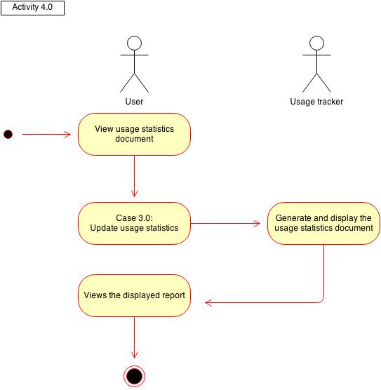

Place here the activity diagram. Make sure that the diagram is grouped as one and text does not wrap around the diagram.

Postcondition: Successful completion: The program displays the usage statistics document.

Relationships: This use case includes Use Case 3.0: Update Usage Statistics.

Special Requirements: NONE

